INTERNATIONAL CONFERENCE 2026
International Conference on Multidisciplinary Research and Innovations in Science, Technology, Management, and Sustainability
(IC-MRISTS 2026)
"Exploring Groundbreaking Research, Innovations, and Sustainability for a Better Tomorrow"
Sunday, 28th June 2026
Conference Mode – Online
Organized By
Scicrafthub International Publication

About the Conference
The International Conference on Multidisciplinary Research and Innovations in Science, Technology, Management, and Sustainability (IC-MRISTS 2026) aims to provide a global platform for researchers, academicians, scientists, industry professionals, and students to present innovative research ideas and advancements across multiple disciplines. The conference focuses on promoting interdisciplinary collaboration, knowledge sharing, innovation, and sustainable development through academic and scientific discussions.
About the Organizer
Scicrafthub International Publication is a distinguished academic publishing and research promotion organization that is dedicated to supporting and advancing high-quality scholarly output across a diverse range of multidisciplinary domains. With a steadfast commitment to academic excellence, Scicrafthub emphasizes the importance of thorough peer review, strict adherence to research ethics, and the promotion of transparency in all aspects of the research process.
Our goal is to foster a global academic community where groundbreaking research can thrive, and where scholars can collaborate internationally to enhance the visibility and impact of their work. By publishing across various fields of study, we provide a platform for innovative ideas, while ensuring that each publication adheres to the highest standards of quality and integrity.
Scicrafthub is driven by a vision to empower researchers and academics by offering a space where their contributions are not only recognized but also made accessible to a global audience. With a focus on increasing the global reach of academic research, we are committed to bridging the gap between disciplines and nations, allowing for cross-border exchange of knowledge and ideas.
Through our dedication to scholarly excellence, we strive to make a lasting contribution to the academic community and support the professional growth of researchers worldwide.
Conference Objectives
- Promote multidisciplinary research and innovation
- Encourage global academic collaboration
- Provide publication opportunities in reputed journals and edited books
- Support young researchers and scholars
- Discuss emerging trends in science, technology, and sustainability
Conference Themes
- Engineering & Technology
- Computer Science & Artificial Intelligence
- Management, Commerce & Economics
- Medical & Pharmaceutical Sciences
- Environmental & Agricultural Sciences
- Social Sciences & Humanities
- Law, Education & Policy Studies
Important Dates
- Abstract Submission Deadline: 20th June 2026
- Acceptance Notification: 22nd June 2026
- Full Paper Submission: 24th June 2026
- Conference Date: 28th June 2026
Publication Opportunities
Selected papers will be published in the following with a processing charge:
Peer-Reviewed Journal | Edited Book (ISBN)|Web of Science Indexed Journal| Scopus Indexed Journal
Submission Categories _ Registration Fee
- UG / PG Student - ₹500
- Research Scholar - ₹1000
- Faculty - ₹1500
- Foreign Delegates - ₹2000
Registration Link: https://forms.gle/k56pwS28t2F5on8eA

Presentation Mode
- Online Presentation
- Oral Presentation Session
- E-Certificates for Participants & Presenters
Awards & Recognition
1st Best Paper Presentation Award
2nd Best Paper Presentation Award
3rd Best Paper Presentation Award
Selected participants may also receive special recognition for outstanding research contribution and presentation excellence.
Eligibility
- Students
- Research Scholars
- Faculty Members
- Scientists
- Industry Professionals
- Independent Researchers
- Benefits of Participation
- International Presentation Platform
- Publication Opportunity
- Networking with Researchers & Experts
- E-Certificate of Participation
- Academic Recognition
- Skill & Research Enhancement
Submission Guidelines
Authors are requested to submit original and unpublished research papers aligned with the conference themes. Papers should follow standard academic formatting and plagiarism guidelines.
Contact Information & QR Code
Dr. Sneha Khadse
📞 WhatsApp: 9372502092
📧 Email: scicrafthubpublication@gmail.com

Payment Details


Account holder - SCICRAFTHUB PUBLICATION

Account Number -924020009548085

IFSC code - UTIB0003998

Bank - Axis Bank

Branch - Titwala, Thane

9372502092@axixbank

Registration Link: https://forms.gle/k56pwS28t2F5on8eA

Note: Once Payment Done Share the Screenshots on the given mail or Whatsapp.

Editorial Board & Advisory Board Committee

Editor-in-Chief
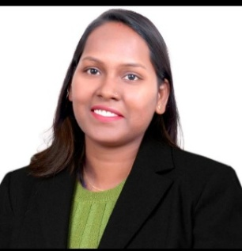 | Dr. Sneha Khadse  Editor-inChief @ ijis.co.in  Publisher@ Scicrafthub International Publication  WhatsApp: +91 9372502092  Email: scicrafthubpublication@gmail.com

Coordinator
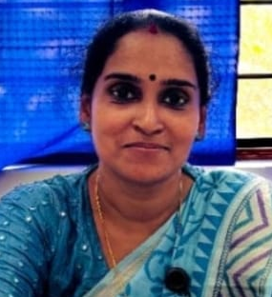 | Dr. Sajitha A V  Associate Professor,  Department of Computer Applications,  Mohandas College of Engineering and Technology, Anad, Thiruvananthapuram, Kerala

Advisory Boards
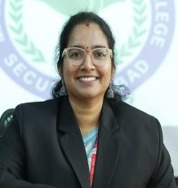 | Dr. Swathi Nalla, Professor  Pharmacology,  Malla Reddy Pharmacy College,  JNTUH, Hyderabad,  Telangana, India
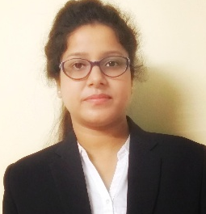 | Dr. Soumi Chakraborty  Assistant Professor-II  Amity Institute of Food Technology  Amity University  Noida, Uttar Pradesh  India
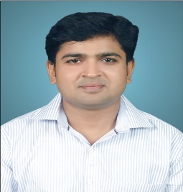 | Dr. Alok Kumar  Assistant Professor  Department of Commerce  RGSC, Banaras Hindu University  Varanasi, Uttar Pradesh  India
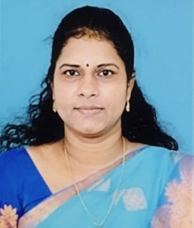 | Dr. A. Nancy  Assistant Professor  Department of Computer Science and Applications, SRM Institute of Science and Technology, SRM University (Deemed to be University), Tiruchirappalli Campus, Tamil Nadu, India
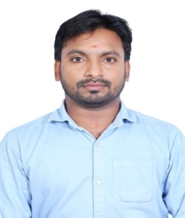 | Dr. Murugavel K  Assistant Professor  Department of Plant Pathology  School of Agricultural Sciences, Amrita Vishwa Vidyapeetham  Coimbatore, Tamil Nadu  India
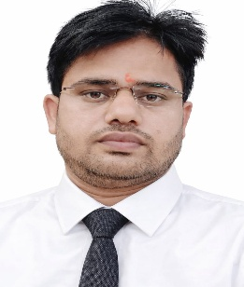 | Dr. Praveen Kumar  Assistant Professor  Department of Management Studies  Marwadi University, Rajkot, Gujarat  Rajkot, Gujarat  India

Technical Board
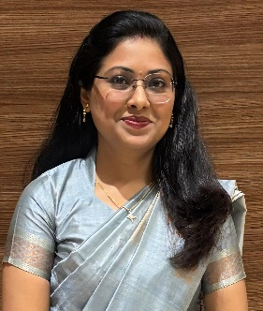 | Nivedita Bhardwaj  Assistant Professor  Department of Pharmaceutical Chemistry  Dr. D.Y. Patil Institute of Pharmaceutical Sciences and Research, Pimpri  Pune, Maharashtra  India
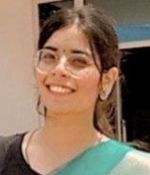 | Dr. Sakshi Rathi  Assistant Professor  Department of Faculty of Humanities  Satyam College of Education, affiliated to SNDT Women’s University, Mumbai  Noida, Uttar Pradesh  India
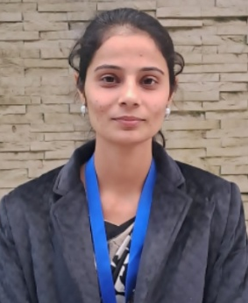 | Vishakha Babal  Research Scholar  SLAS Department  Mody University of Science and Technology  Lakshmangarh, Rajasthan  India
 | Aliefia Lehri  Assistant Professor  Department of Pharmacognosy  Prin K M Kundnani College of Pharmacy  Mumbai, Maharashtra  India
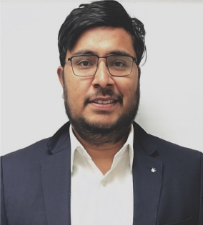 | Abhaysingh Deshmukh  Project Manager  Department of Project Management  Lamar University, Beaumont, Texas, USA  Allentown, Pennsylvania (PA)  USA

